**Assignment – 1**

**Tasks To Be Performed:**

1. Deploy a Kubernetes cluster for 3 nodes

2. Create a NGINX deployment of 3 replicas

1. Created 3 instances.

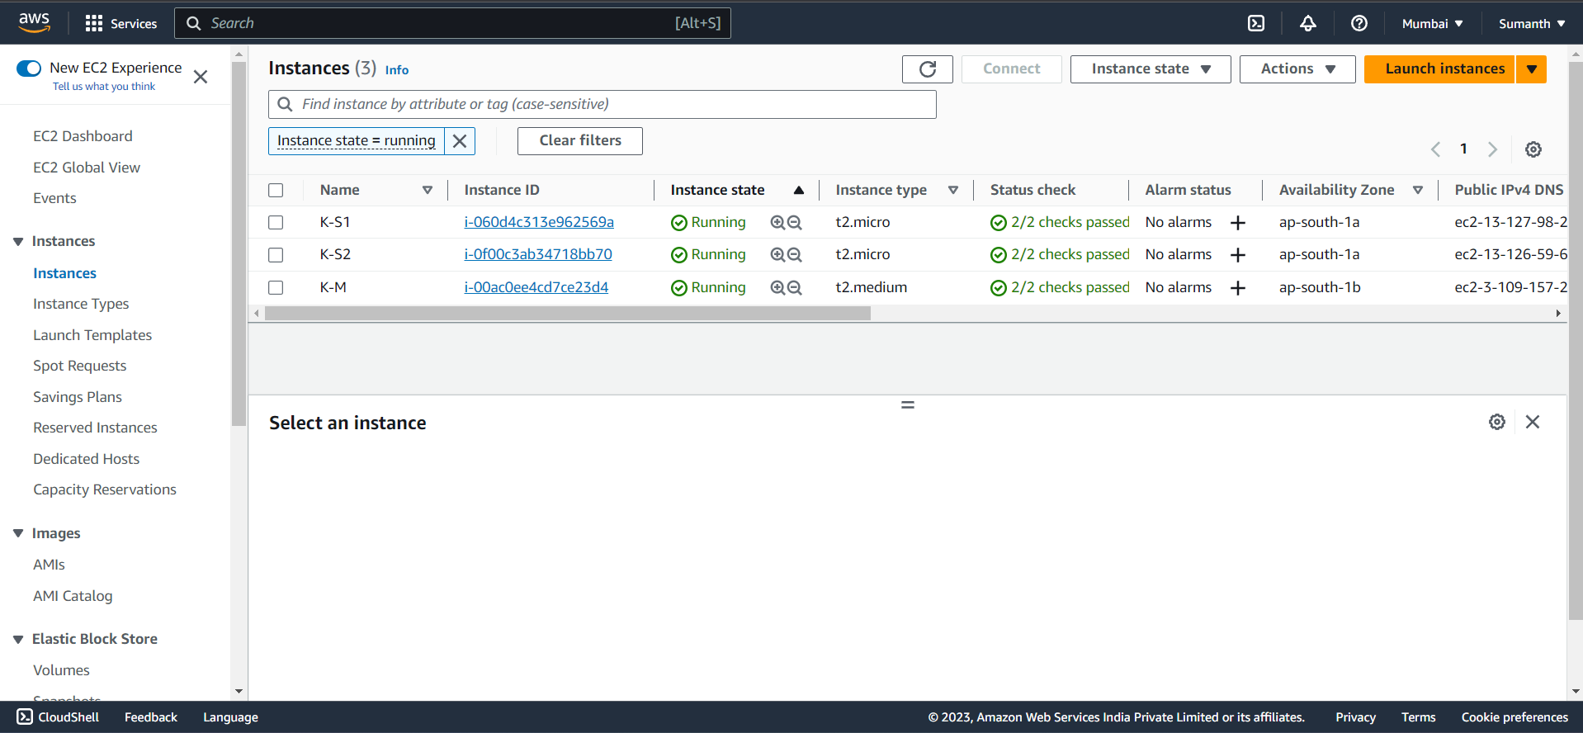

1. Installed docker in all the 3 nodes
2. Created a file **a.sh** and ran the required commands in all 3 nodes

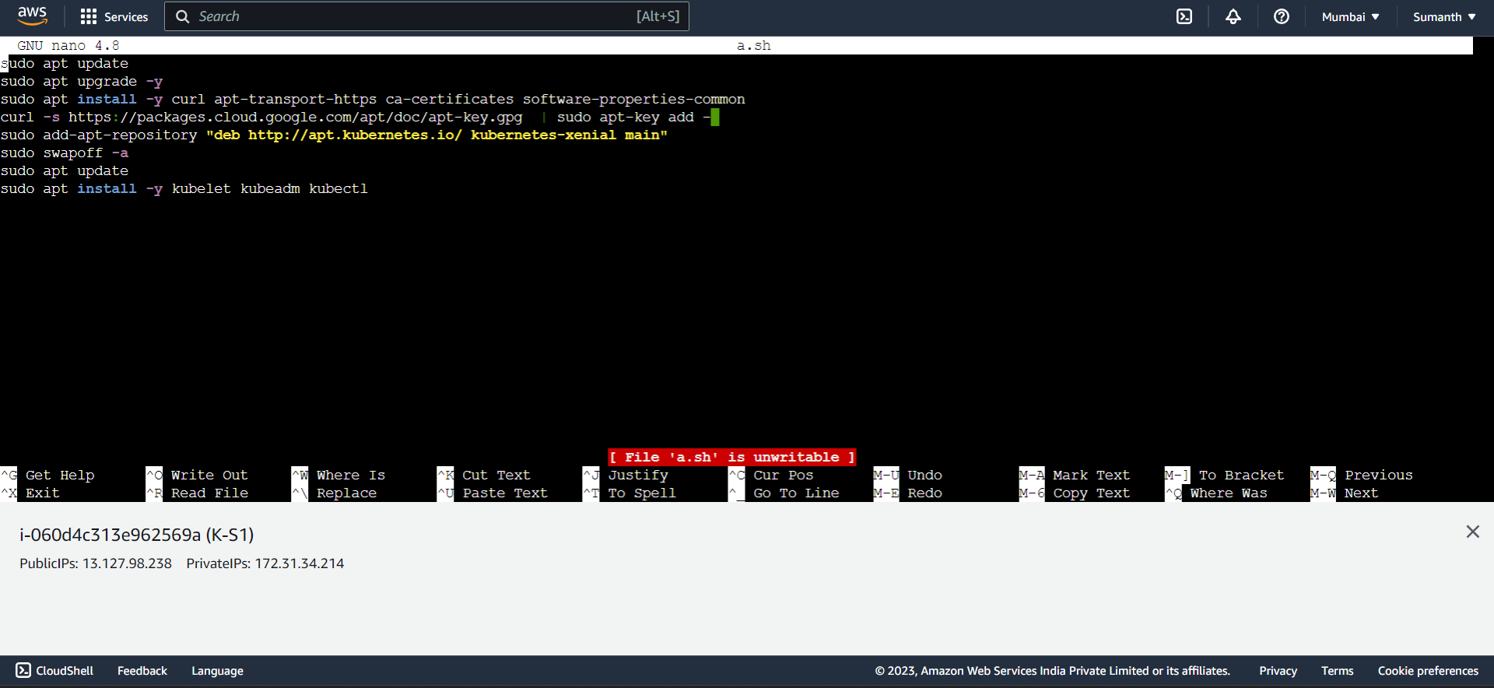

1. Initiated the cluster in Master

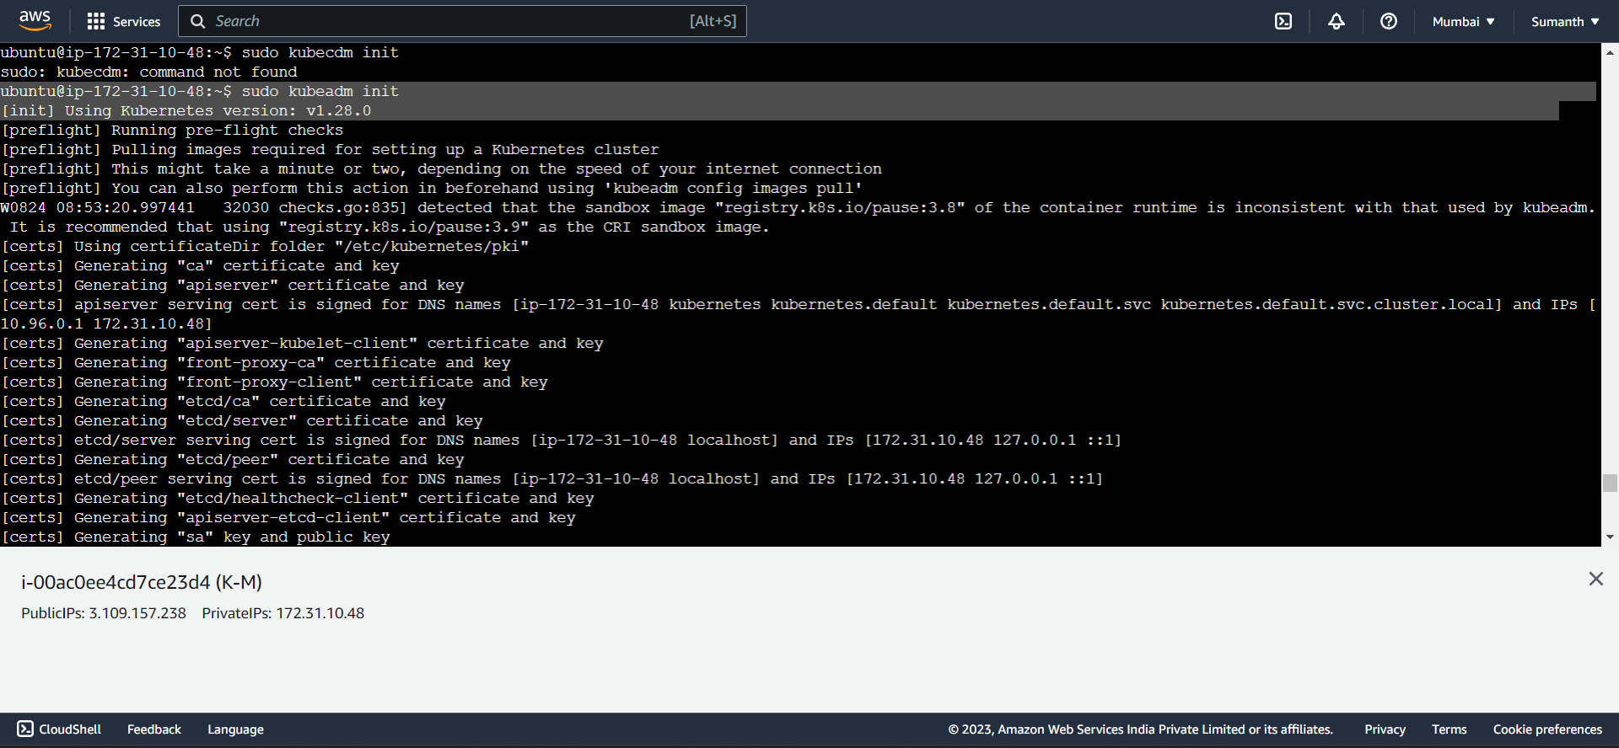

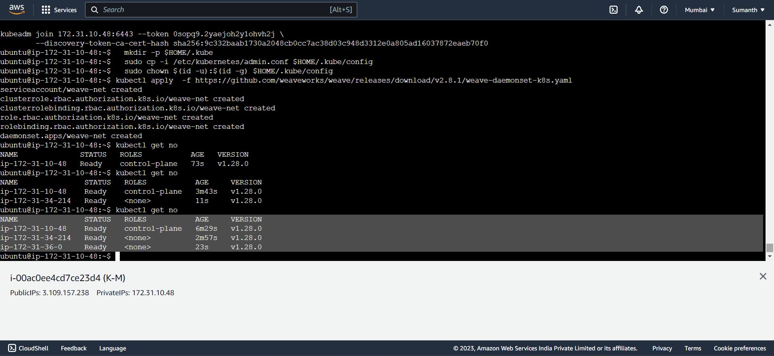

1. Created a YAML file for Deployment

